**Server Virtualization**

Server Virtualization is the act of dividing a physical server into multiple and unique isolated servers by means of software applications. Each virtual server can run its own operating system independently.

**Benefits of Server Virtualisation**

**Efficiency:**

Creating new VMs from already generated VM template

We can add resource on-demand.

We can clone existing Virtual Machine.

Can administer VMs from single console.

Can take snapshot before upgrades or changes.

**Agility:**

Rapidly deploy new applications

Rapidly scale up new applications

**Availability:**

What is virtualized in software becomes relatively independent of hardware.

Availability that was once very difficult and expensive becomes standard

In traditional method if server is down then down no way but here if one server is down then other part can be used

**Time:**

Save time in administering the server.

Save time protecting data

Save time deploying new applications

Save time replacing aging hardware.

**Money:**

Lower administering charges.

Low infra charges

Less cooling cabling switching charge

**How Server Virtualization works?**

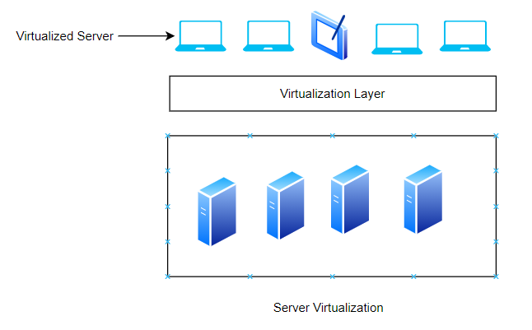

**Server Virtualization** has virtualization layer that runs on top allows us to virtualize server that normally run on physical host.

**Hypervisors**

**TYPE – 1 Hypervisor vs. TYPE – 2 Hypervisor**

Type 2 Hypervisor

* Loaded in an OS running on hardware
* Examples:
* Worksatation/Fusion
* Oracle VM
* Parallels

Type 1 Hypervisor

* Loaded directly on the hardware
* Examples:
* Hyper V
* ESXi
* KVM

**Virtual Host:-**

The physical server along with virtualization layer is called virtual host.

**Virtual Machine:-**

The software contained OS and Apps running on the top of virtualization layer.

**Virtualization Layer:-**

Virtualization layer makes virtual resources (CPU, Memory , OS , network) available to each VM in very proper way . It provides pointer to physical server.

1. Virtual CPU
2. Virtual Memory
3. Virtual Disk
4. Virtual Network

**How to virtualize server?**

1. **P2V Conversion Tool** :- P2V is the process of converting and transferring a physical computer image (its operating system, data and application) into a virtual machine (VM). Two approaches you can use with P2V are hot P2V (conducted while the physical server is running) and cold P2V (performed when the server OS is not running)
2. **Backup , install the OS in the VM and then recover**